

Research Methods for Managers
Continuous Assessment Assignment: 2
Semester: 2
Batch: 2025-27
Date: 27/02/2026

Questionnaire & Survey research

Topic: A Study on the Impact of Financial Literacy on Investment Decision-Making Among Young Professionals.
Sl. N  o | Registration Number | Name of the Student | (a) | (b) | (c) | Total
1 | 25030302052 | Sumiran Chettri
Faculty Comments:

Faculty Signature Dr. Raja Sankaran
CO2 | Develop a Research proposal for a Research project on a business-related  topic;
CO3 | Understand different phases of a Research process in a Research project.
CO4 | Develop appropriate data collection instruments

Introduction
Financial literacy has become increasingly important in today’s complex financial environment young professionals are exposed to multiple investment opportunities such as mutual funds, equities, bonds, and retirement products. However, the ability to make sound investment decisions depends largely on their level of financial knowledge and understanding.
This study aims to examine whether financial literacy significantly influences investment decision-making among young professionals.
Objectives of the Study
The objective of this study is to measure the level of financial literacy among young professionals their investment decision making behavior and to examine the relationship between financial literacy and investment decision making.
Identification of Variables
The Variables in the study are:
Independent variable: Financial Literacy which is measured using 6 Likert scale questions related to:
- Compound interest
- Inflation
- Risk-return relationship
- Investment product awareness
- Financial information seeking
- Financial evaluation ability
Dependent variable: Investment Decision Making which is measured using 6 Likert scale questions related to:
- Risk analysis
- Diversification
- Comparing alternatives
- Long-term planning
- Portfolio review
- Decision confidence

Identification of Relationship Between Variables
The study consists of two primary variables: Financial Literacy and Investment Decision-Making. Financial Literacy is treated as the independent variable as it represents the explanatory factor influencing financial behaviour. Investment Decision-Making is considered the dependent variable as it reflects the outcome influenced by financial knowledge.
The study assumes a positive relationship between financial literacy and investment decision-making it is expected that individuals with higher levels of financial literacy are more likely to make informed, rational, and diversified investment decisions. Therefore, financial literacy is hypothesized to significantly predict investment behaviour among young professionals.
Design of the Scale (Likert Scale)
To measure the relationship of Financial Literacy and Investment Decision-Making a structured questionnaire was developed using a 5-point Likert scale.
The response categories were:
Scale Value | Response Category
1 | Strongly Disagree
2 | Disagree
3 | Neutral
4 | Agree
5 | Strongly Agree

This scale allows respondents to express varying degrees of agreement and ensures measurable quantitative data for statistical analysis.

Independent Variable: Financial Literacy measured using 6 questions:

  - I understand how compound interest affects long-term investments.
  - I understand how inflation impacts the real value of money.
  - I understand the relationship between risk and return in investments.
  - I am able to differentiate between various investment instruments such as stocks, mutual funds, and bonds.
  - I feel confident in my ability to evaluate financial products before investing.
  - I regularly seek financial information before making investment decisions.

Dependent Variable: Investment Decision-Making measured using 6 questions:

  - I carefully analyse potential risks before making an investment.
  - I diversify my investments to reduce overall risk.
  - I compare multiple investment alternatives before choosing one.
  - I prefer long-term investment planning over short-term speculation.
  - I periodically review and adjust my investment portfolio.
  - I am confident in the investment decisions I make.

Screenshot of Survey Responses Collected from Young Professionals

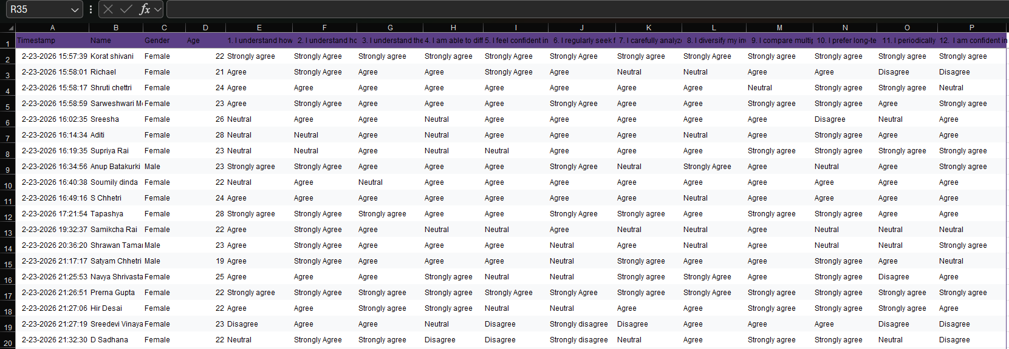
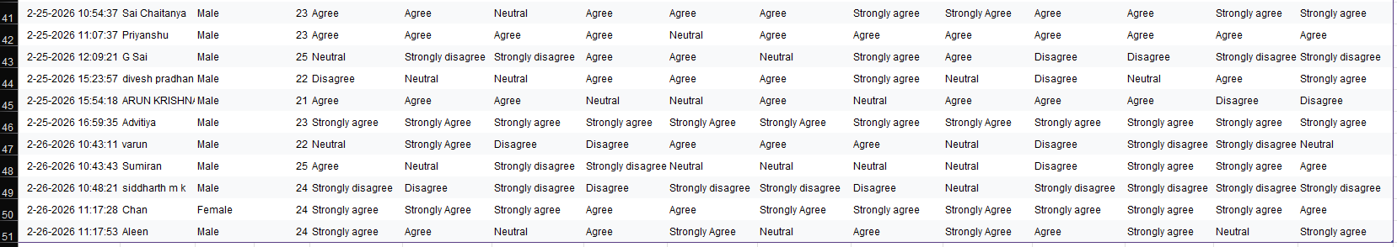
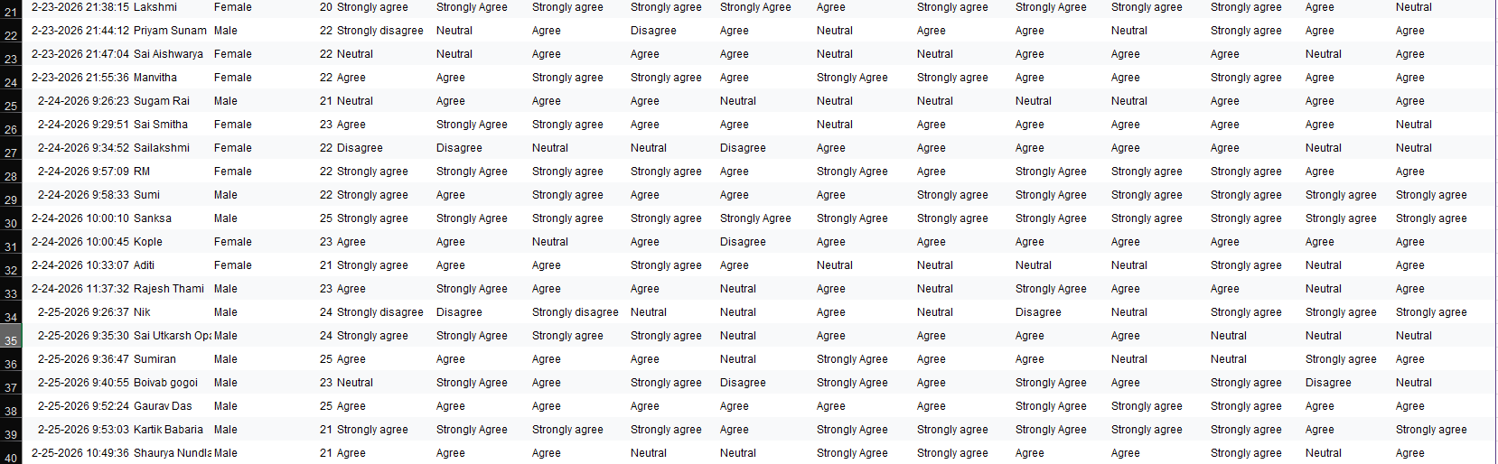

The above screenshot presents a portion of the raw survey responses collected through Google Forms from 50 young professionals. The questionnaire consisted of 12 Likert-scale items measuring Financial Literacy (6 items) and Investment Decision-Making (6 items). The responses were recorded on a 5-point scale ranging from 1 (Strongly Disagree) to 5 (Strongly Agree).

Formulating hypothesis for the chosen variables

Null Hypothesis (Ho)
H0: Financial literacy has no significant impact on investment decision-making among young professionals.

$Ho: β=0$

Alternative Hypothesis (H1)
H1: Financial literacy has a significant positive impact on investment decision-making among young professionals.

$H1: β ≠0$

Let:
- X = Financial Literacy
- Y = Investment Decision-Making
- β = Regression coefficient

Data Collection
- Method: Online Google Form Survey
- Sample Size: 50 respondents
- Target Population: Young professionals

Data Analysis and Results

Descriptive Statistics:

Financial Literecy Score |  | Investment Literecy Score
Mean | 3.856666667 | Mean | 3.956667
Standard Error | 0.110144206 | Standard Error | 0.101999
Median | 4 | Median | 4
Mode | 4 | Mode | 4
Standard Deviation | 0.778837147 | Standard Deviation | 0.721244
Sample Variance | 0.606587302 | Sample Variance | 0.520193
Kurtosis | 1.093874421 | Kurtosis | 1.81334
Skewness | -0.829659177 | Skewness | -0.94235
Range | 3.666666667 | Range | 3.5
Minimum | 1.333333333 | Minimum | 1.5
Maximum | 5 | Maximum | 5
Sum | 192.8333333 | Sum | 197.8333
Count | 50 | Count | 50
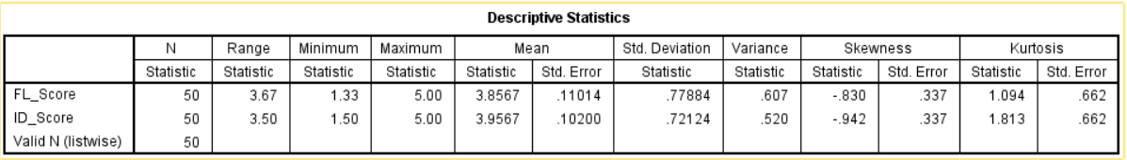
The mean financial literacy score of 3.86 indicates that young professionals generally possess a moderately high level of financial literacy.
The median and mode both equal 4, suggesting that most respondents selected “Agree” for financial literacy-related statements.
The standard deviation (0.78) shows moderate dispersion meaning responses are relatively consistent and not highly scattered.
The negative skewness (-0.83) indicates that responses are slightly concentrated toward the higher end of the scale (Agree/Strongly Agree) meaning most participants perceive themselves as financially knowledgeable.
The range (3.67) shows that although most responses are high there is some variation among respondents.

The mean investment decision-making score of 3.96 suggests that respondents generally demonstrate strong and rational investment behaviour.
The median and mode are both 4, indicating that the majority of respondents agree with statements reflecting good investment practices.
The standard deviation (0.72) is slightly lower than that of financial literacy indicating even greater consistency in investment decision behaviour.
The negative skewness (-0.94) shows responses are concentrated toward higher values meaning most young professionals report positive investment decision habits.

Correlation Analysis:
SPSS:

Correlations
 |  | FL_Score | ID_Score
FL_Score | Pearson Correlation | 1 | .703**
 | Sig. (2-tailed) |  | .000
 | N | 50 | 50
ID_Score | Pearson Correlation | .703** | 1
 | Sig. (2-tailed) | .000
 | N | 50 | 50
**. Correlation is significant at the 0.01 level (2-tailed).

Using EXCEL :

 | Correlation
 | Financial Literecy Score | Investment Literecy Score
Average Financial Literecy Score | 1
Average Investment Literecy Score | 0.703223255 | 1

r = 0.703
Interpretation:
There is a strong positive relationship between financial literacy and investment decision-making among young professionals.

Regression Analysis

Variables Entered/Removedª
Model | Variables Entered | Variables Removed | Method
1 | FL_Score^{b} | . | Enter
a. Dependent Variable: ID_Score
b. All requested variables entered.

Model Summary
Model | R | R Square | Adjusted R Square | Std. Error of the Estimate
1 | .703ª | .495 | .484 | .51810
a. Predictors: (Constant), FL_Score

ANOVAª
Model |  | Sum of Squares | df | Mean Square | F | Sig.
1 | Regression | 12.605 | 1 | 12.605 | 46.960 | .000^{b}
 | Residual | 12.884 | 48 | .268
 | Total | 25.489 | 49
a. Dependent Variable: ID_Score
b. Predictors: (Constant), FL_Score

Coefficientsª
Model |  | Unstandardized Coefficients |  | Standardized Coefficients | t | Sig.
 |  | B | Std. Error | Beta
1 | (Constant) | 1.445 | .374 |  | 3.866 | .000
 | FL_Score | .651 | .095 | .703 | 6.853 | .000
a. Dependent Variable: ID_Score

Using EXCEL:

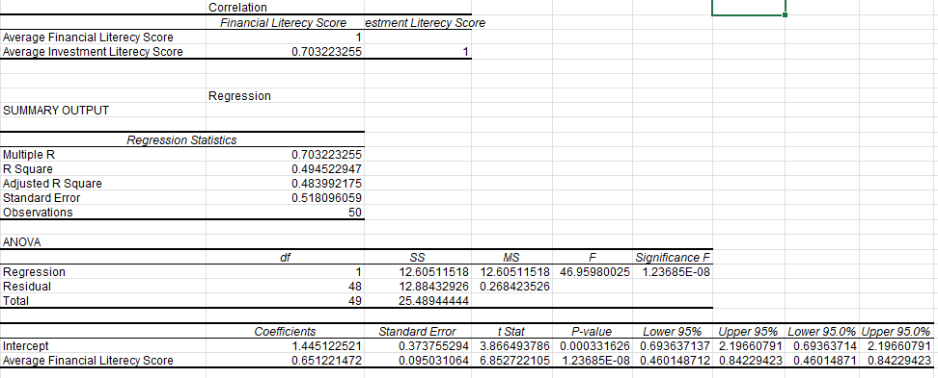

- R² = 0.495
- F = 46.96
- p-value = 1.24E-08
Interpretation:
The regression model is statistically significant (p < 0.05). Financial literacy explains 49.5% of the variation in investment decision-making.
The regression coefficient (β = 0.651) indicates that for every one-unit increase in financial literacy, investment decision-making increases by 0.651 units.

Reliability Analysis (Cronbach’s Alpha)

Financial Literacy Scale

Case Processing Summary
 |  | N | %
Cases | Valid | 50 | 63.3
 | Excludedª | 29 | 36.7
 | Total | 79 | 100.0
a. Listwise deletion based on all variables in the procedure.

Reliability Statistics
Cronbach's Alpha | Cronbach's Alpha Based on Standardized Items | N of Items
.854 | .853 | 6

Inter-Item Correlation Matrix
 | @1Iunderstandhowcompoundinterestaffectslongterminvestme | @2Iunderstandhowinflationimpactstherealvalueofmoney | @3Iunderstandtherelationshipbetweenriskandreturninin | @4Iamabletodifferentiatebetweenvariousinvestmentinstrum | @5Ifeelconfidentinmyabilitytoevaluatefinancialproducts | @6Iregularlyseekfinancialinformationnewsreportsexpe
@1Iunderstandhowcompoundinterestaffectslongterminvestme | 1.000 | .679 | .593 | .615 | .533 | .507
@2Iunderstandhowinflationimpactstherealvalueofmoney | .679 | 1.000 | .703 | .425 | .344 | .360
@3Iunderstandtherelationshipbetweenriskandreturninin | .593 | .703 | 1.000 | .574 | .340 | .344
@4Iamabletodifferentiatebetweenvariousinvestmentinstrum | .615 | .425 | .574 | 1.000 | .441 | .470
@5Ifeelconfidentinmyabilitytoevaluatefinancialproducts | .533 | .344 | .340 | .441 | 1.000 | .458
@6Iregularlyseekfinancialinformationnewsreportsexpe | .507 | .360 | .344 | .470 | .458 | 1.000

Summary Item Statistics
 | Mean | Minimum | Maximum | Range | Maximum / Minimum | Variance | N of Items
Inter-Item Correlations | .492 | .340 | .703 | .363 | 2.067 | .014 | 6

Item-Total Statistics
 | Scale Mean if Item Deleted | Scale Variance if Item Deleted | Corrected Item-Total Correlation | Squared Multiple Correlation | Cronbach's Alpha if Item Deleted
@1Iunderstandhowcompoundinterestaffectslongterminvestme | 19.360 | 14.072 | .783 | .644 | .801
@2Iunderstandhowinflationimpactstherealvalueofmoney | 19.020 | 15.693 | .665 | .615 | .826
@3Iunderstandtherelationshipbetweenriskandreturninin | 19.240 | 14.880 | .668 | .587 | .825
@4Iamabletodifferentiatebetweenvariousinvestmentinstrum | 19.280 | 15.798 | .662 | .499 | .827
@5Ifeelconfidentinmyabilitytoevaluatefinancialproducts | 19.520 | 16.908 | .537 | .342 | .848
@6Iregularlyseekfinancialinformationnewsreportsexpe | 19.280 | 16.287 | .540 | .335 | .849

Financial Literacy Scale
Your Result:
- Cronbach’s Alpha = 0.854
Interpretation
The reliability of the Financial Literacy scale was assessed using Cronbach’s Alpha. The obtained value of 0.854 indicates a high level of internal consistency among the six items measuring financial literacy.
Since the value exceeds the recommended threshold of 0.70, the scale is considered reliable and suitable for further statistical analysis. This suggests that the items consistently measure the underlying construct of financial literacy.

Case Processing Summary
 |  | N | %
Cases | Valid | 50 | 63.3
 | Excludedª | 29 | 36.7
 | Total | 79 | 100.0
a. Listwise deletion based on all variables in the procedure.

Reliability Statistics
Cronbach's Alpha | Cronbach's Alpha Based on Standardized Items | N of Items
.822 | .823 | 6

Inter-Item Correlation Matrix
 | @7Icarefullyanalyzepotentialrisksbeforemakinganinvestm | @8Idiversifymyinvestmentstoreduceoverallrisk | @9Icomparemultipleinvestmentalternativesbeforechoosing | @10Ipreferlongterminvestmentplanningovershorttermspec | @11Iperiodicallyreviewandadjustmyinvestmentportfolio | @12IamconfidentintheinvestmentdecisionsImake
@7Icarefullyanalyzepotentialrisksbeforemakinganinvestm | 1.000 | .485 | .375 | .310 | .384 | .413
@8Idiversifymyinvestmentstoreduceoverallrisk | .485 | 1.000 | .615 | .367 | .223 | .255
@9Icomparemultipleinvestmentalternativesbeforechoosing | .375 | .615 | 1.000 | .617 | .426 | .389
@10Ipreferlongterminvestmentplanningovershorttermspec | .310 | .367 | .617 | 1.000 | .572 | .411
@11Iperiodicallyreviewandadjustmyinvestmentportfolio | .384 | .223 | .426 | .572 | 1.000 | .698
@12IamconfidentintheinvestmentdecisionsImake | .413 | .255 | .389 | .411 | .698 | 1.000

Summary Item Statistics
 | Mean | Minimum | Maximum | Range | Maximum / Minimum | Variance | N of Items
Inter-Item Correlations | .436 | .223 | .698 | .474 | 3.122 | .018 | 6

Item-Total Statistics
 | Scale Mean if Item Deleted | Scale Variance if Item Deleted | Corrected Item-Total Correlation | Squared Multiple Correlation | Cronbach's Alpha if Item Deleted
@7Icarefullyanalyzepotentialrisksbeforemakinganinvestm | 19.720 | 14.696 | .512 | .337 | .809
@8Idiversifymyinvestmentstoreduceoverallrisk | 19.680 | 15.038 | .497 | .468 | .812
@9Icomparemultipleinvestmentalternativesbeforechoosing | 19.780 | 13.196 | .653 | .565 | .780
@10Ipreferlongterminvestmentplanningovershorttermspec | 19.520 | 12.744 | .629 | .499 | .785
@11Iperiodicallyreviewandadjustmyinvestmentportfolio | 20.080 | 12.157 | .651 | .594 | .781
@12IamconfidentintheinvestmentdecisionsImake | 19.920 | 12.973 | .604 | .518 | .791

Alpha ≈ 0.80+ (acceptable to good)
Interpretation
The Investment Decision-Making scale also demonstrated acceptable reliability, with Cronbach’s Alpha exceeding 0.80, indicating good internal consistency.
This confirms that the items used to measure investment behavior are coherent and reliably capture the construct.

Hypothesis Testing
Since p-value (1.24E-08) < 0.05:
- Reject Ho
- Accept H1
Conclusion:
Financial literacy has a statistically significant positive impact on investment decision-making among young professionals.

Conclusion
The findings of the study confirm that financial literacy significantly influences investment decision-making. Young professionals with higher financial awareness tend to evaluate risks carefully, diversify investments, and engage in long-term financial planning.

Managerial Implications
- Organizations should conduct financial literacy workshops for employees.
- Financial institutions should design educational investment programs.
- Policymakers should strengthen investor awareness initiatives.
- Employers may integrate financial wellness programs into HR policies.
Limitations
- Sample size limited to 50 respondents.
- Data collected through self-report measures.
- Study restricted to young professionals only.
- Only one independent variable examined.

Theoretical Linkage Between Survey Items and Literature

Article (APA Style) | Survey Question Derived / Supported | Justification
(Lusardi & Mitchell, 2014) | I understand how compound interest affects long-term investments. | Lusardi & Mitchell identify understanding of compound interest as a core component of financial literacy and essential for long-term wealth accumulation and retirement planning.
(HUSTON, 2010) | I understand how compound interest affects long-term investments. | Huston defines financial literacy as knowledge and application of financial concepts such as compounding and time value of money.
(LUSARDI & MITCHELL, 2011) | I understand how inflation impacts the real value of money. | Inflation knowledge is one of the “Big Three” financial literacy questions and is crucial for effective financial planning.
(van Rooij et al., 2011) | I understand the relationship between risk and return in investments. | The study shows that individuals who understand the risk-return tradeoff are more likely to participate in financial markets.
(Allgood & Walstad, 2016) | I understand the relationship between risk and return in investments. | Both actual and perceived financial literacy influence investment behaviour through risk comprehension.
(HUSTON, 2010) | I am able to differentiate between various investment instruments such as stocks, mutual funds, and bonds. | Financial literacy includes the ability to apply financial knowledge in practical decision-making situations, including product awareness.
(Calcagno & Monticone, 2015) | I feel confident in my ability to evaluate financial products before investing. | Financially literate individuals exhibit higher confidence and reduced reliance on external financial advice.
(Fernandes et al., 2014) | I regularly seek financial information before making investment decisions. | Financial literacy influences downstream financial behaviors, including information search and informed decision-making.
(Aren & Zengin, 2016) | I carefully analyse potential risks before making an investment. | Risk perception significantly influences investment choices, linking literacy to risk analysis behaviour.
(Lusardi & Mitchell, 2014) | I diversify my investments to reduce overall risk. | Financial literacy is positively associated with portfolio diversification and rational asset allocation.
(Calcagno & Monticone, 2015) | I compare multiple investment alternatives before choosing one. | Financial knowledge improves evaluation and comparison of financial products before decision-making.
(Bernheim et al., 2001) | I prefer long-term investment planning over short-term speculation. | Financial education increases long-term saving behaviour and discourages short-term financial decisions.
(Fernandes et al., 2014) | I periodically review and adjust my investment portfolio. | Financial literacy improves ongoing financial management and portfolio monitoring behaviour.
(Allgood & Walstad, 2016) | I am confident in the investment decisions I make. | Perceived financial literacy enhances financial confidence and decision quality.

References

(Allgood & Walstad, 2016).The effects of perceived and actual financial literacy on financial behaviors. Economic Inquiry, 54(1), 675–697

(Aren & Zengin, 2016). Influence of financial literacy and risk perception on choice of investment. Procedia – Social and Behavioral Sciences, 235, 656–663.

(Bernheim et al., 2001). Education and saving: The long-term effects of high school financial curriculum mandates. Journal of Public Economics, 80(3), 435–465.

(Calcagno & Monticone, 2015). Financial literacy and the demand for financial advice. Journal of Banking & Finance, 50, 363–380.

(Fernandes et al., 2014). Financial literacy, financial education, and downstream financial behaviors. Management Science, 60(8), 1861–1883.

(Garg & Singh, 2018). Financial literacy among youth. International Journal of Social Economics, 45(1), 173–186.

(HUSTON, 2010). Measuring financial literacy. Journal of Consumer Affairs, 44(2), 296–316.

(LUSARDI & MITCHELL, 2011). Financial literacy and retirement planning in the United States. Journal of Pension Economics & Finance, 10(4), 509–525.

(Lusardi & Mitchell, 2014). The economic importance of financial literacy: Theory and evidence. Journal of Economic Literature, 52(1), 5–44.

(van Rooij et al., 2011). Financial literacy and stock market participation. Journal of Financial Economics, 101(2), 449–472.

